Online Appendix for
Panoramic Sales Insight: Using Explainable Deep Learning to Improve the Effectiveness of Flash Sales

Appendix A. Proportion of Each Primary Category among All Products
Appendix B. Comparison of Visual Features between Best-Selling and Slow-Selling Products
Appendix C. Comparison of Text Description and Review Keywords between Best-Selling and Slow-Selling Products
Appendix D. Most Common and Least Common Text Descriptions and Comments
Appendix E. Hyperparameters for Multimodal Fusion Methods in Forecasting Revenue
Appendix F. Comparison of Revenue Forecasting and Real Values

Appendix A. Proportion of Each Primary Category among All Products

Tables A1. Sales volume for primary and secondary categories
Production category | Frequency | Percentage (%)
Panel A. Primary category
Women’s clothing | 571 | 24.8
Curve | 450 | 19.6
Sports & outdoor | 241 | 10.5
Jewelry & accessories | 223 | 9.7
Men’s clothing | 185 | 8.0
Beauty & health | 127 | 5.5
Underwear & sleepwear | 122 | 5.3
Baby & maternity | 121 | 5.3
Beachwear | 96 | 4.2
Electronics | 40 | 1.7
Others | 124 | 5.3
Panel B. Secondary category
Women’s tops | 291 | 12.7
Curve tops | 236 | 10.3
Women’s beachwear | 193 | 8.4
Women’s activewear | 159 | 6.9
Men’s tops | 98 | 4.3
Curve dresses | 72 | 3.1
Baby girls’ clothing (0–3Yrs) | 52 | 2.3
Maternity clothing | 50 | 2.2
Women’s bottoms | 50 | 2.2
Curve bottoms | 48 | 2.1
Others | 1051 | 47.7
Total | 2300 | 100

Appendix B. Comparison of Visual Features between Best-Selling and Slow-Selling Products
Tables B1. Visual features of best-selling products
Secondary category | Image | Image feature
Women Tops | 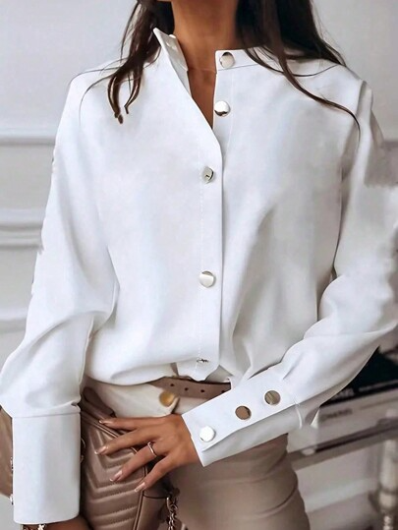 | White, Casual, Plain, Shirt, Button, Collar, Long Sleeve, Regular Sleeve, Regular, Regular Fit, Slight Stretch, Polyester, 100% Polyester.
Women Tops | 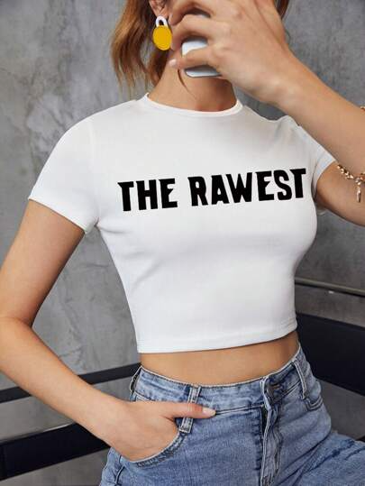 | Black, Casual, Letter, Round Neck, Backless, Short Sleeve, Regular Sleeve, Crop, Regular Fit, Slight Stretch, Fabric, 95% Polyester, 5% Elastane, White, Slogan.
Body Jewelry & Others | 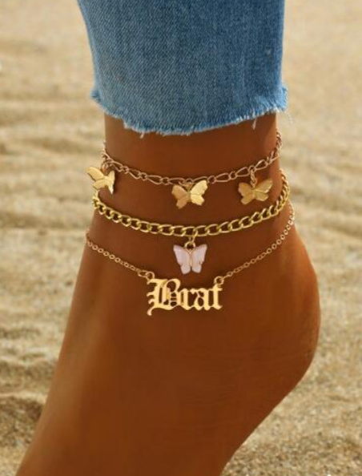 | Women, Gold, No, Zinc Alloy.

Tables B2. Visual Features of Slow-Selling Products
Secondary category | Image | Image feature
Women Bags | 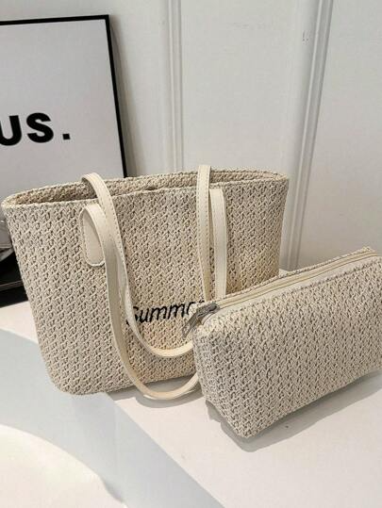 | Beige, Ruched, Yes, Straw Bag, Casual, Double Handle, Tropical, Magnet, Vacation, Paper, Textured Pattern
Women Activewear | 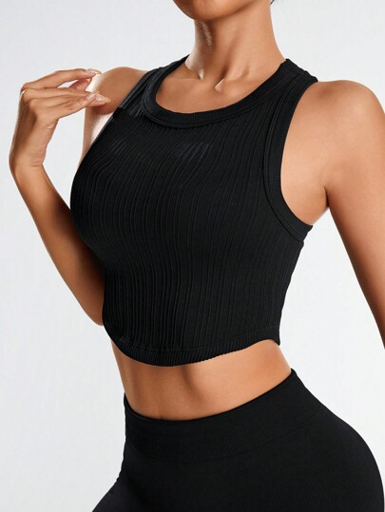 | Black, Rib-Knit, Plain, Sleeveless, Crop, Round Neck, Slim Fit, Seamless, Medium Stretch, Fabric, 90% Polyamide, 10% Elastane, Machine wash
Women Belts & Accessories | 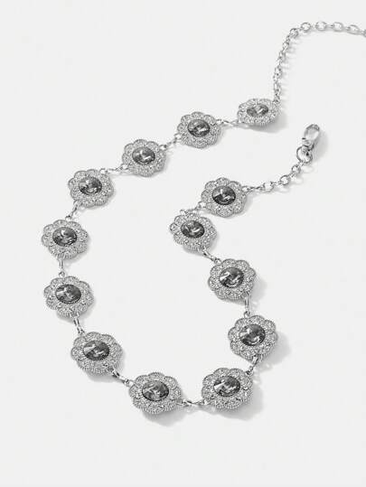 | Silver, Zinc Alloy, Elegant, Sexy, Party, Other, one-size

Appendix C. Comparison of Text Description and Review Keywords between Best-Selling and Slow-Selling Products

Tables C1. Example of text description and review keywords for best-selling and slow-selling products
Product name | Review keywords | Text description
Best-selling products in flash sales
SHEIN VCAY Plus Size Women's Casual Print Stand Collar Long Shirt | Recommend, clear, flattering, elegant, lovely | White, boho, button, sheer, split, shirt, floral, short sleeve, stand collar, flounce sleeve, slit, regular, loose, non-stretch, woven fabric, 100% polyester, machine wash, do not dry clean, wash with the soft detergent, semi-sheer, blue, embroidery, plants, flared, navy blue, apricot, ruffle hem, red
SHEIN EZ Wear Casual Letter Printed Cropped T-Shirt for Summer | Recommend, cute, happy, compliments, elegant | Black, casual, letter, round neck, backless, short sleeve, regular sleeve, crop, regular fit, slight stretch, fabric, 95% polyester, 5% elastane, machine wash or professional dry clean, white, slogan
SHEIN Swim Summer Beach Ladies' Floral Print Swimsuit Set | Supporting, fan, fav, playing, solid | Swimsuit fabric, 85% polyester, 15% elastane, pink, cute, floral, ruffle, twist, high waist, wireless bra, straps, high stretch, machine wash, do not dry clean
Slow-selling products in flash sales
SHEIN LUNE Plus Size Patchwork Graphic Short Sleeve Casual T-Shirt for Summer | Recommend, sure, dislike, leave, compliments | Multicolor, casual, color block, patchwork, all over print, round neck, short sleeve, batwing sleeve, regular, regular fit, high stretch, fabric, 95% polyester, 5% elastane, machine wash, do not dry clean, wash with the soft detergent, purple, geometric
SHEIN LUNE Women's Summer Asymmetrical Contrast Lace Round Neck Short Sleeve Casual T-Shirt | Happy, ignore, bright, flattering, tops | Green, casual, color block, asymmetrical neck, asymmetrical, contrast lace, raglan sleeve, short sleeve, regular, regular fit, medium stretch, knitted fabric, 66% polyester, 28% viscose, 6% elastane, machine wash or professional dry clean, white
SHEIN Swim SPRTY Summer Beach Sports Color block Bikini Set | Cutest, complain, tired, struggled, beauty | Swimsuit fabric, 82% polyester, 18% elastane, black and white, casual, color block, striped, zipper, contrast binding, square neck, high stretch, hand wash or professional dry clean, high waist

Appendix D. Most Common and Least Common Text Descriptions and Review Keywords
Tables D1. Most common and least common text descriptions and comments
Most common | N-gram score | Least common | N-gram score
Comment emotion keywords
Love | 0.3540 | Reach | 0.0001
Cute | 0.3040 | Stress | 0.0001
Like | 0.1406 | Thankful | 0.0001
Super | 0.1160 | Torn | 0.0001
Nice | 0.1055 | Trick | 0.0001
Fit | 0.0973 | Truly | 0.0001
Perfect | 0.0803 | Worst | 0.0001
Great | 0.0595 | Awful | 0.0001
Comfortable | 0.0562 | Comforting | 0.0001
Top | 0.0510 | Defects | 0.0001
Text description
Wash | 0.2583 | Style zinc | 0.0001
Stretch | 0.2350 | Suede | 0.0001
Dry | 0.2293 | Suede warm | 0.0001
Clean | 0.2283 | Suit | 0.0001
Polyester | 0.2283 | Suit alcohol | 0.0001
Dry clean | 0.2282 | Sun | 0.0001
No | 0.1946 | Sun camel | 0.0001
Regular | 0.1908 | Super | 0.0001
Fabric | 0.1882 | Super high | 0.0001
Elastane | 0.1849 | Support baby | 0.0001

Appendix E. Hyperparameters for Multimodal Fusion Methods in Forecasting Revenue
This appendix summarizes the ranges of hyperparameters for all deep learning models and the corresponding specifications.
Tables E1. Ranges of hyperparameters for all deep learning models
 | FCN | LSTM | RNN
Specification | Learning rate ∈ {0.01,0.1,0.2,0.3}  n estimators ∈{200,500,1000,2000} Layers ∈{2,3,4,5} Activation function ∈ {ReLU, Sigmoid, LeakyReLU} | Learning rate ∈ {0.01,0.1,0.2,0.3}  n estimators ∈{200,500,1000,2000} Layers ∈{2,3,4,5}  Activation function ∈ {ReLU, Sigmoid, LeakyReLU} | Learning rate ∈ {0.01,0.1,0.2,0.3}  n estimators ∈{200,500,1000,2000}  Layers ∈{2,3,4,5} Activation function ∈ {ReLU, Sigmoid, LeakyReLU}
 | ANN | DNN | CNN
Specification | Learning rate ∈ {0.01,0.1,0.2,0.3}  n estimators ∈{200,500,1000,2000}  Layers ∈{2,3,4,5} Activation function ∈ {ReLU, Sigmoid, LeakyReLU}  Regularization ∈{L1, L2}  Optimizer ∈ {adam,sgd, RMSprop} | Learning rate ∈ {0.01,0.1,0.2,0.3}  n estimators ∈{200,500,1000,2000}  Layers ∈{2,3,4,5} Activation function ∈ {ReLU, Sigmoid, LeakyReLU}  Regularization ∈{L1, L2}  Optimizer ∈ {adam,sgd, RMSprop} | Learning rate ∈ {0.01,0.1,0.2,0.3}  n estimators ∈{200,500,1000,2000}  Layers ∈{2,3,4,5} Activation function ∈ {ReLU, Sigmoid, LeakyReLU}  Filter size ∈ {3*3,5*5}  Pooling ∈{max,average}

Appendix F. Comparison of Revenue Forecasting and Real Values

Figures F1. Absolute difference between the predicted values and the true values for each model
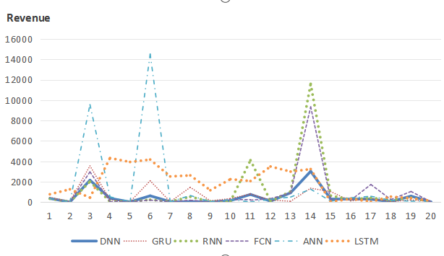
In Appendix F online, this study randomly selects 20 data points from the model and compares the actual predicted revenue with the true revenue. LSTM, RNN, GRU, ANN, and FCN are also selected as the comparison groups. The results show that the DNN architecture is superior to the other deep learning architectures in the vast majority of the 20 cases. For some products, the predicted revenue is close to the actual revenue.

